Masks preparation

------------------

As noted, only single band (not classified) .tif files used as masks, make sure they each have an extent. You can add as many as you want in the masks folder. A method is described in this readme on how to convert a classified raster to a single band raster.

If you have a classified tiff file and want to convert it to a single band then you can use QGIS.

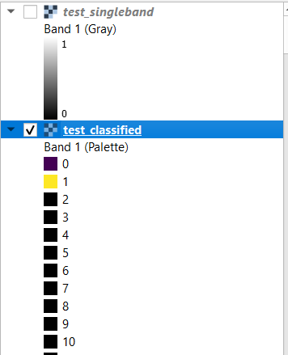

- Open QGIS and load the classified tiff layer

- Open the raster calculater (raster --> raster calculator) and perform the calculation "classified_raster_band@1" * 1.

- Save it into a new tiff file

- Use this new singleband tiff file as your mask in the assets/masks folder

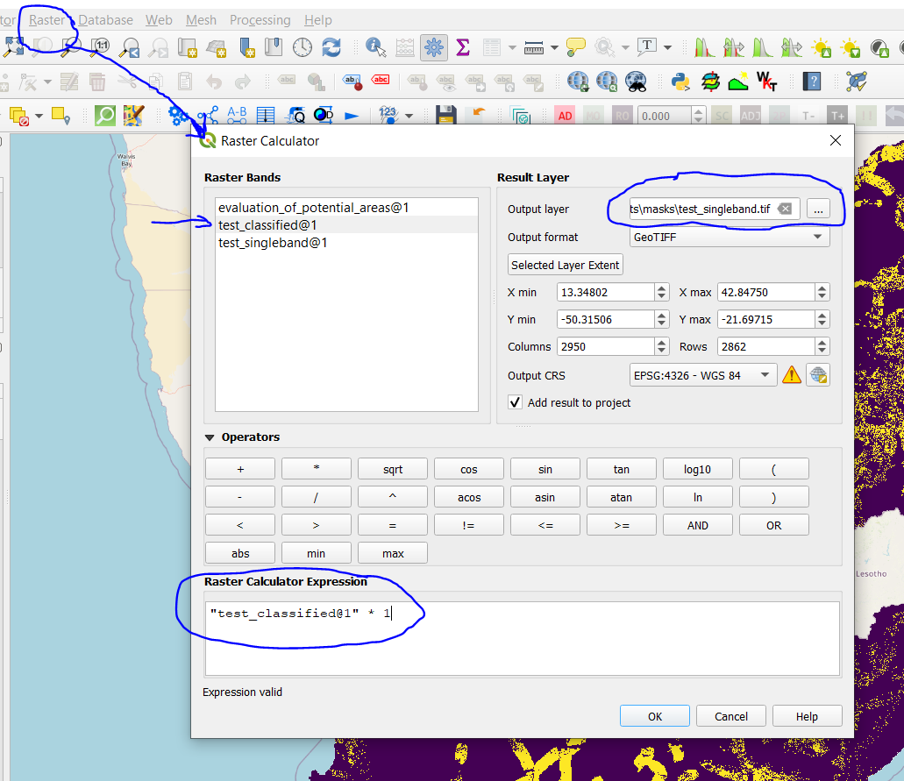

Please remove all classified masks (or rename the extension) from the assets/masks folder so that it doesnt load them, this is to save you some run time.